
Job Description
Activities Assistant

Location | Aldwins House
Department | Activities
Responsible to | Facility Manager
Purpose of Position | To provide residents with activity opportunities that will enhance their daily living in a meaningful and dignified manner.

Key Accountabilities
- Support meaningful individual and group activities for residents as planned by the Diversional Therapist.
- Discuss any suggested changes to the programme according to results of evaluations with the Diversional Therapist.
- Maintain comprehensive and robust resident documentation.
- Ensure a weekly/monthly activities programme calendar is available for residents, families and staff.
- Maintain and/or establish links with community groups or organisations in the interests of residents.
- Participate and assist in regular resident meetings.
- Participate in quality-related activities.
- Participate in professional development and at times including attendance at regional DT group meetings as directed by the Facility Manager.
- Encourage and support volunteers who wish to assist with the activities programme.

Qualifications and Experience
- Current, clear driver’s license
- Experience in Aged Care sector
- Experience in or knowledge of implementing and evaluating a Diversional Therapy Programme

skills, knowledge and abilities
- Excellent communicator
- The ability to motivate people
- Good problem solving and analytical skills
- A high standard of personal integrity, discretion and tact, maintaining confidentiality
- Ability to handle pressure
- Team player
- Planning and organisational ability.
- Knowledge of art and craft techniques, and sporting and cultural activities.
- Knowledge of safety issues and CPR training.

general responsibilities as a promisia employee
Te Tiriti O Waitangi
- Promisia is committed to its obligations under Te Tiriti O Waitangi. As an employee you are required to live out the principles through all you do at work. These principles are Equity, Partnership, Tino Rangatiratanga (autonomy or independence), Options and Protection.

Professional Responsibilities
- At Promisia, we put our Residents first which means we need to always be professionally responsible. It is every employee’s responsibility to ensure they maintain professional registration, keep themselves upskilled and that they are working to best practices.

Confidentiality
- As an employee, you must adhere to the Privacy Act 1993 and the Health Information Privacy Code 1994 as well as its subsequent amendments relating to the non-disclosure of information. Simply put, we treat all personal information of our residents, applicants and staff strictly confidential.

Health & Safety
- Every employee has a responsibility of Health and Safety towards themselves, colleagues and most importantly, our Residents. It means working safely, reporting any risks, adverse events or near misses and support initiatives that minimise risks. Always wear your name badge and report any suspicious activity immediately.
- We are a smoke free organisation and smoking is not permitted within the facility.

agreement
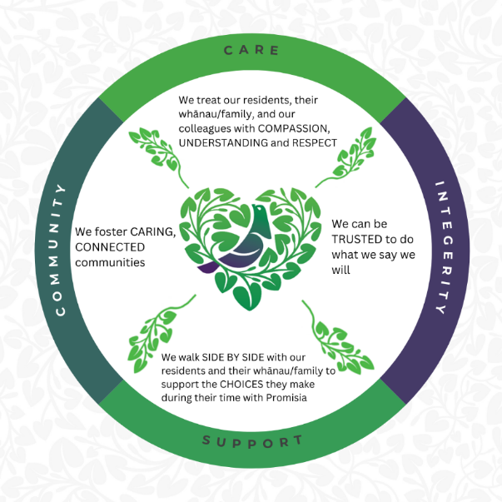
As an employee of Promisia, I agree that:

- I will undertake and perform my duties and tasks identified in this Job Description and as reasonably requested by my employer.
- I will adhere to all our Policies and Procedures.
- I will live out our organisational values and the principles under Te Tiriti O Waitangi in my role.

Employee name: ___________________________

Employee Signature: ___________________________

Date: ___________________________

Manager name: ___________________________

Manager Signature: ___________________________

Date: ___________________________

